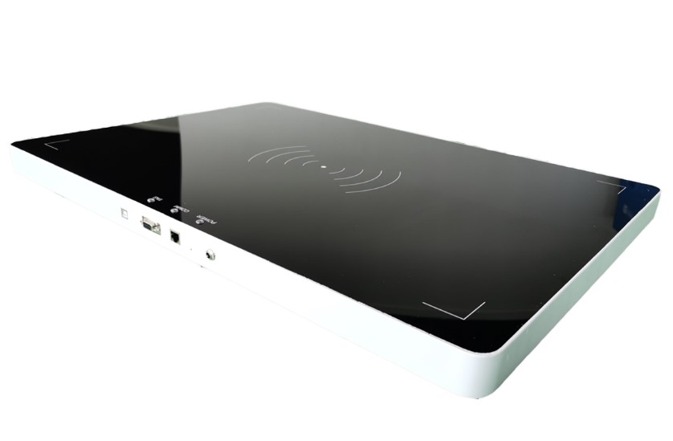

UHF rfid integrated reader
OPP-D03

1.The synopsis of the reader：
The OPP-D03 is a low profile, high-performance UHF rfid integrated reader. Adopt Impinj IndyR2000 chip, with high-performance multi-tag identification algorithms.

The OPP-D03 has built-in Linux operating system, which not only meets the complex customer business requirements, but also responds to various label operations independently and quickly. Multi-tag reading performance is excellent, supporting intensive reading, large capacity tag reading and writing, received signal strength detection (RSSI). It has reliable network adaptability, supports a variety of network protocols, and is easy to deploy large-scale applications.
2.Product features
Mechanical electrical performance
Equipment size Dimension：（MM） |  | 500（L）*700（W）*35（H）（±1）
Net weight： (KG) |  | 6.780（±0.02）
Shell |  | Black acrylic panel, milky white metal bottom shell, the whole machine is black
Antenna |  | integrated 4pcs 8 dBiC antennas
Performance Index
Tag / Transponder Protocols |  | EPCglobal Gen 2 (ISO 18000-6C)、ISO 18000-6B (optional)
Frequency |  | 865~868MHz/902～928MHz（Can be adjusted according to different countries or regions）
RF output |  | from 0 dBm to 30 dBm* with +/-1dBm
Reading distance |  | ＞8m（eg.9662，depends on tag）
Peak inventory speed |  | > 700 tags/sec
Tag RSSI |  | Supported
Antenna Detector |  | Supported
Power |  | With 220V AC input, the output of +12 V/5A DC power converter
Communication interface |  | RJ45(10/100 Base-T Ethernet)、RS232、USB (for debugging)
Operating System |  | Linux
Communication protocol |  | RS-232、TCP/IP、 Modbus、HTTP/HTTPS、MQTT、RabbitMQ
Host API |  | C#、JAVA
Development Environment |  | Linux、Android、Windows、PLC、Web
Environment
Operating Temp | -20～+55℃
Storage Temp | -20～+85℃
Humidity | 5%～95%RH，Non-condensing

- Interface diagram：

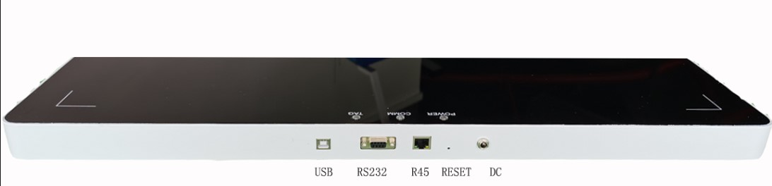

Figure 2

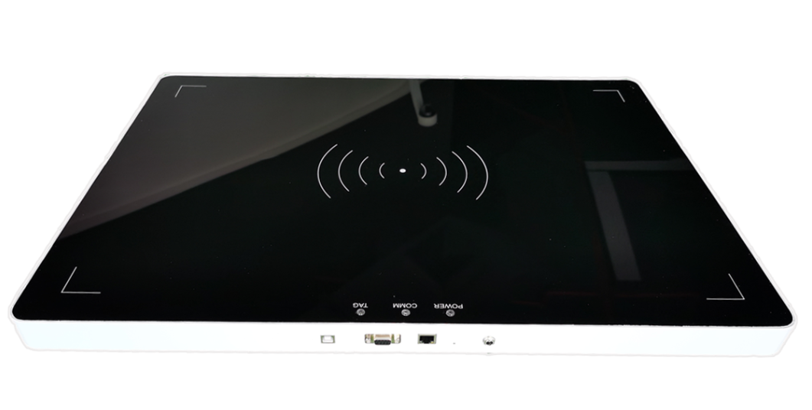Figure 3

