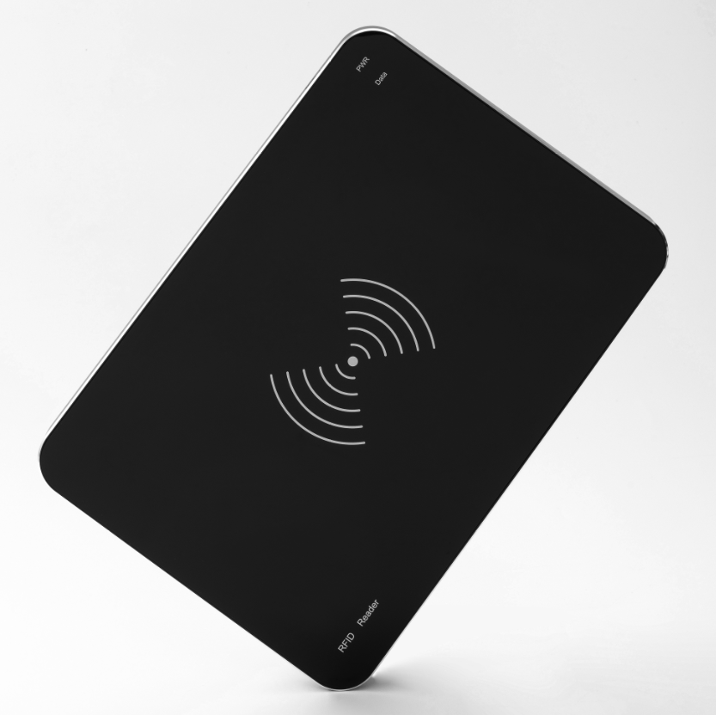

UHF rfid integrated reader

OPP-D02

1.
OPP-D02 is a high-performance UHF RFID desktop integrated reader, Based on the design of high-performance UHF chip,it fully supports the EPCglobal C1 Gen 2 ISO 18000-6c standard.Combined with the proprietary high-efficiency collision processing algorithm, while maintaining a high reading rate.
OPP-D02 is suitable for RFID solutions such as logistics,warehousing,express delivery,store management,and financial management.

2.Product parameters：
Mechanical electrical performance
Dimension:（MM） | 320（L）*225（W）*17（H）（±1）
Diemension including packaging（MM） | 370（L）*270（W）*55（H）（±3）
Net weight:(KG) | 0.94（±0.1）
Gross weight:(KG） | 1.23（±0.1）
Shell | Acrylic panel, metal bottom shell, the whole reader is black
Performance Index
RFID Protocol Support | EPCglobal Gen 2 (ISO 18000-6C)
RF Transceiver | Default: MagicRF M100,  IMPINJ E310 Optional
RF Antenan | Built-in a circularly polarized antenna，The gain of the antenna ＞ 0dBi
Frequency | 865~868MHz/902～928MHz（Can be adjusted according to different countries or regions）
Receiver Sensitivity | MagicRF M100:-69dBm
Receiver Sensitivity | IMPINJ E310:-74dBm
RF Power Output | MagicRF M100:from 0 dBm to 26dBm(±1 adjustable)
RF Power Output | IMPINJ E310:from 5 dBm to 27dBm(±1 adjustable)
Reading distance | MagicRF M100:＞0.8m（eg.9662，depends on tag）
Reading distance | IMPINJ E310:＞2m（eg.9662，depends on tag）
Peak inventory speed | MagicRF M100:>50 tags/sec
 | MPINJ E310:>200 tags/sec
Tag RSSI | Supported
Antenna Detector | Supported
Indicator light | PWR:Red LED,Power indicator  Data:Green LED,Successfully reading the tags will light up green
Power | 5V,500mA（MAX）
Communication interface | USB type C
Certification | CE、ROHS
API support | C#、JAVA
Environment
Operating Temp | -20～+55℃
Storage Temp | -20～+85℃
Humidity | 5%～95%RH，Non-condensing

3.The product image:
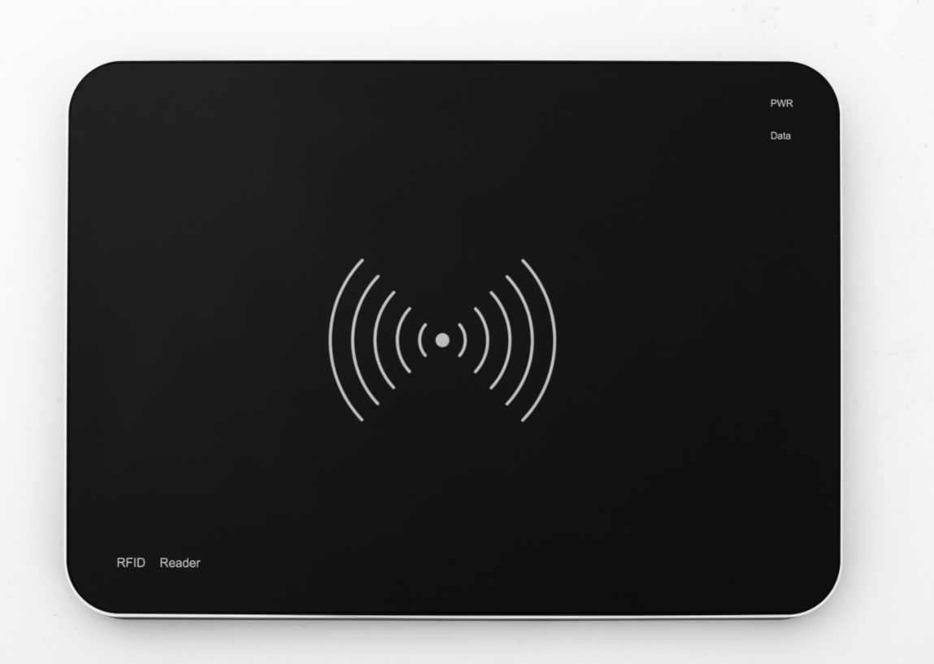

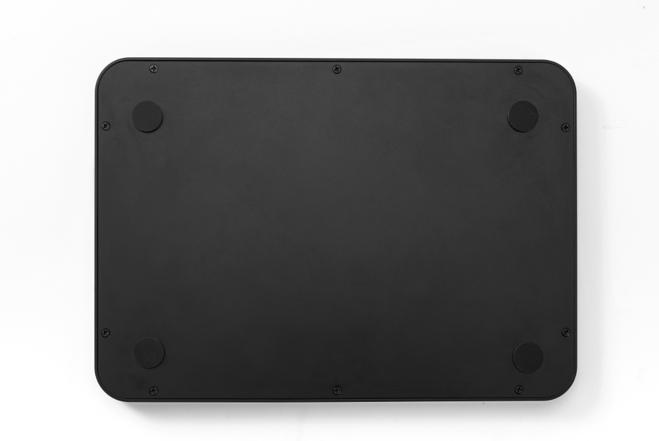

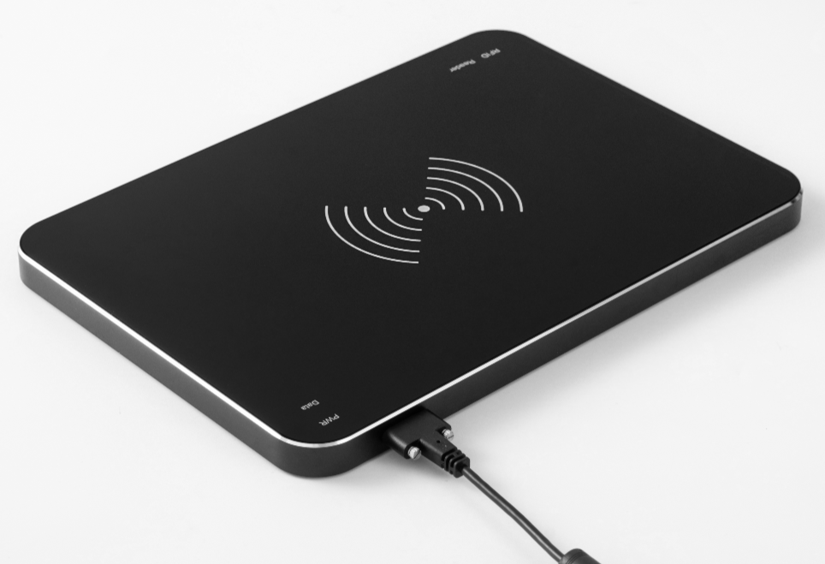
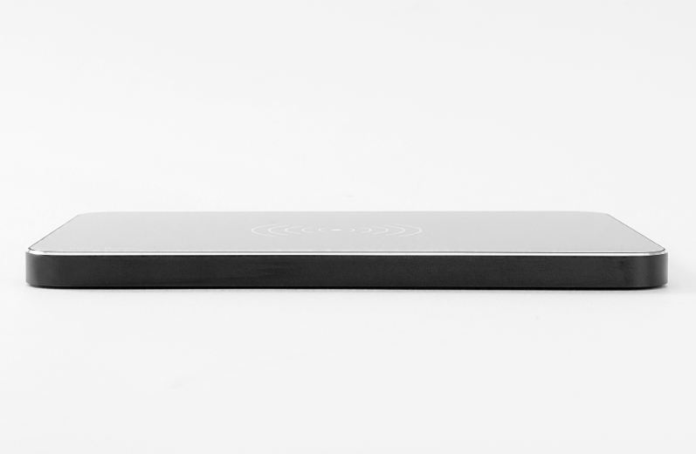
Figure 2 Figure 3

Figure 4 Figure 5

- Directional diagram of the built-in antenna:

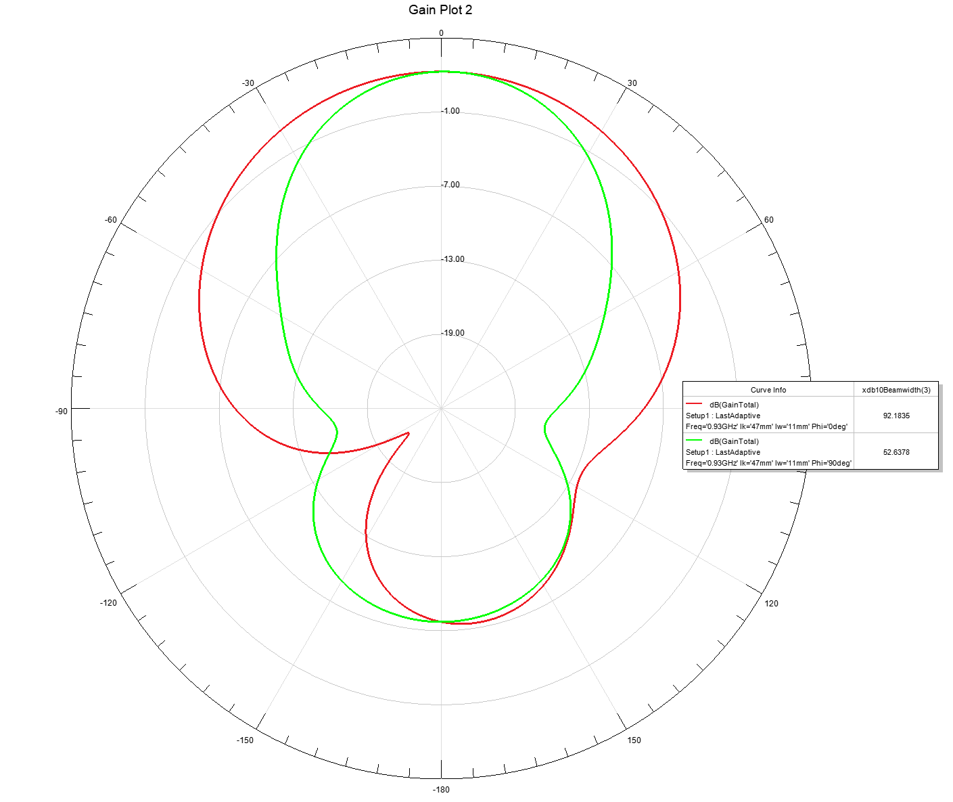
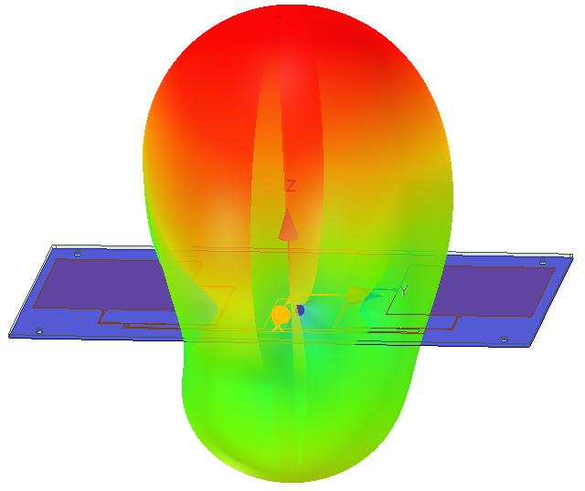

Figure 6 Figure 7
5.MECHANICAL DATA (UNIT:mm)
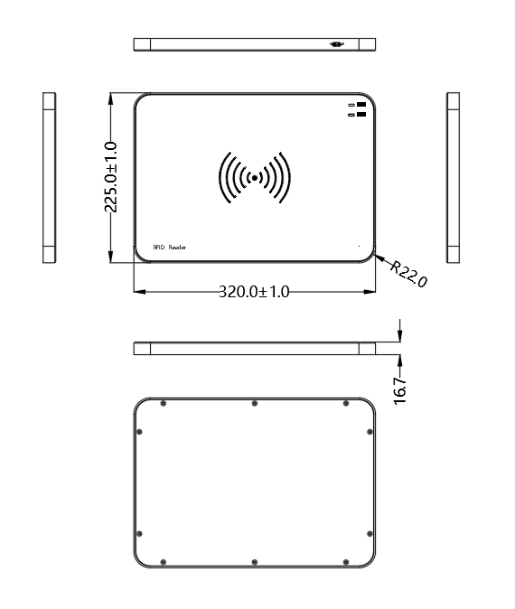

Figure 8

6.Packing List
Name | Model/Description | Number
Reader | OPP-D02 | 1
USB Cable | USB To Type C,The length is 2 meters, with a magnetic ring and supports screw fixation | 1
Package | Paper box+pearl cotton, as shown in the following figure (Figure 9) | 1

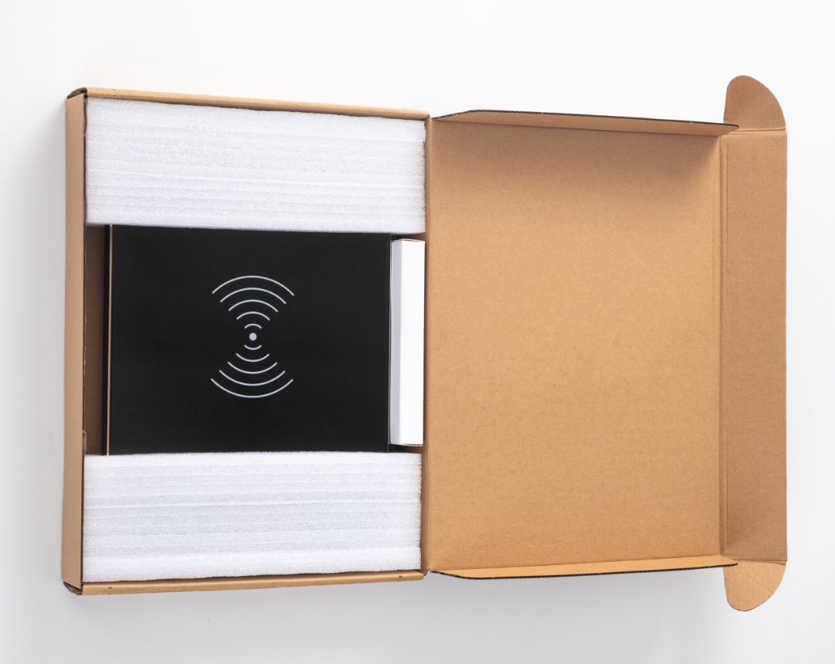

Figure 9

